**Literature Review of Design approach**

**Geographical and climatic in Newman WA**

Site Information

Site name: Newman, WA [1]

Elevation: 544m

Newman, originally named Mount Newman until 1981, is a town in the [Pilbara](https://en.wikipedia.org/wiki/Pilbara_region_of_Western_Australia) region of [Western Australia](https://en.wikipedia.org/wiki/Western_Australia). It is located about 1,186 kilometres north of [Perth](https://en.wikipedia.org/wiki/Perth), and 9 kilometres north of the [Tropic of Capricorn](https://en.wikipedia.org/wiki/Tropic_of_Capricorn). It can be reached by the [Great Northern Highway](https://en.wikipedia.org/wiki/Great_Northern_Highway). Newman is a modern mining town, with homes contrasting with the surrounding reddish desert [2].

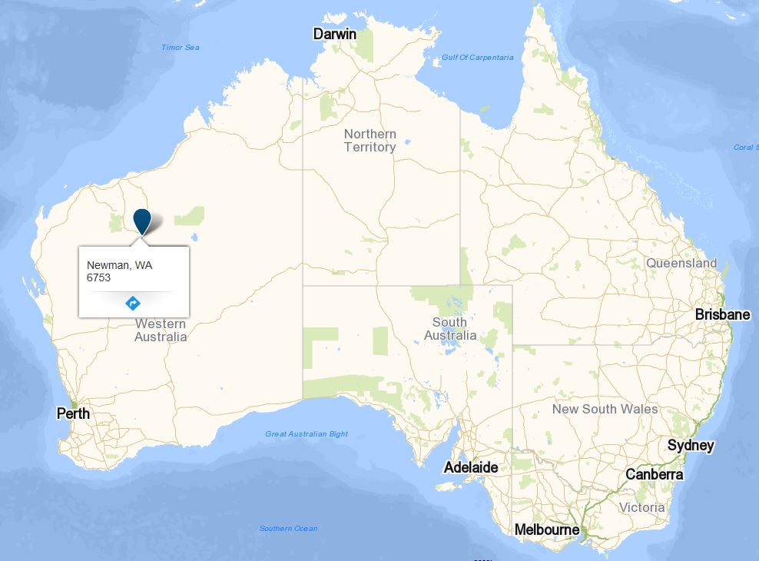

**Figure 1: Newman, WA**

**Climate:**

Newman has a [semi-arid climate](https://en.wikipedia.org/wiki/Semi-arid_climate), with very hot summers and mild winters. The temperature reaches or exceeds 38 °C (100 °F) for many days in the summer. On 15 January 1998, the temperature reached an all-time recorded high of 47 °C (117 °F). [Precipitation](https://en.wikipedia.org/wiki/Precipitation_(meteorology)) is sparse, but the influx of monsoonal moisture in the summer, which generally begins in December and lasts until April, raises humidity levels and can cause occasional heavy storms. Winter months are mild to warm, with daily high temperatures ranging from the 20 °C (68 °F) to 26 °C (79 °F), and low (night-time) temperatures rarely dipping below 6 °C (43 °F).

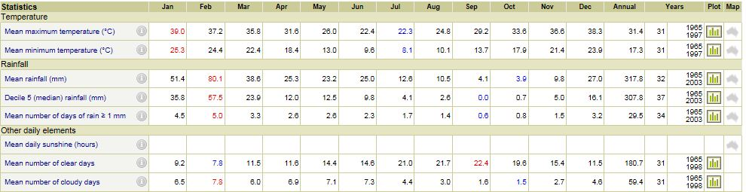

**Figure 2: Mean temperature, rainfall and other daily elements**

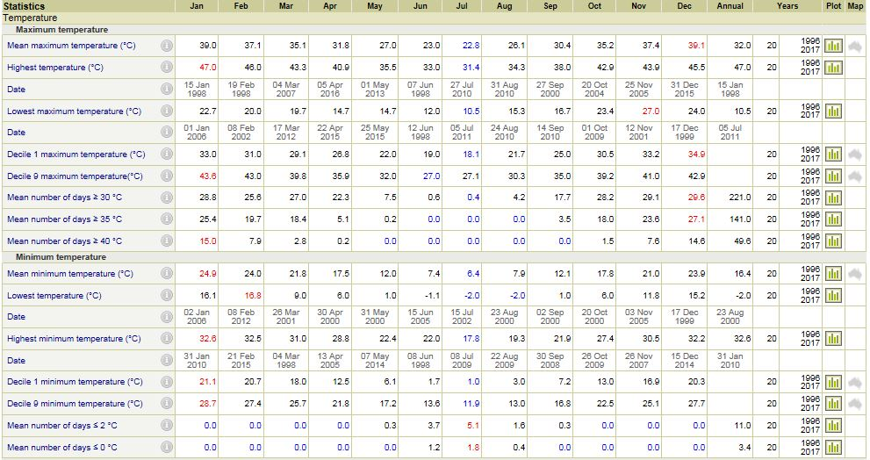

**Figure 3: Statistics Temperature**

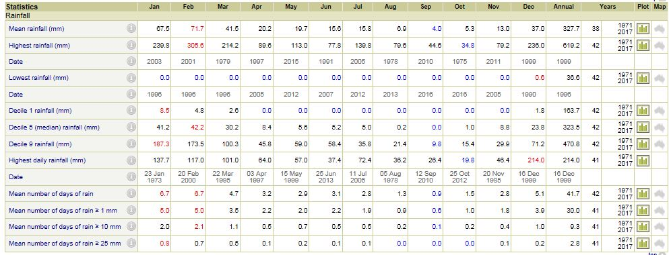

**Figure 4: Statistics Rainfall**

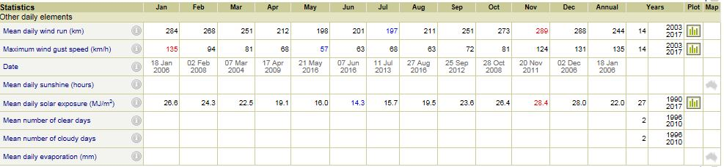

**Figure 5: Statistics other weather conditions**

**Reference**

[1]"Climate statistics for Australian locations", *Bom.gov.au*, (2017, 26/03/2017). Available: http://www.bom.gov.au/climate/averages/tables/cw_007176_All.shtml

[2]"Newman, Western Australia", *En.wikipedia.org*, (2017, 26/03/2017). Available: <https://en.wikipedia.org/wiki/Newman,_Western_Australia>

**LNG: Liquefied Natural Gas** [1]

1. **What is the LNG?**

LNG (liquefied natural gas) is obtained by cooling natural gas at atmospheric pressure to approximately -162 °C, resulting in a fuel that is colourless, odourless and non-toxic. It is transported and stored in liquid form and provided to the customer in gas form. The heavy hydrocarbons in natural gas are removed during the process of liquefaction making LNG cleaner than natural gas and giving it a higher thermal value.

1. **Installation and Activation**

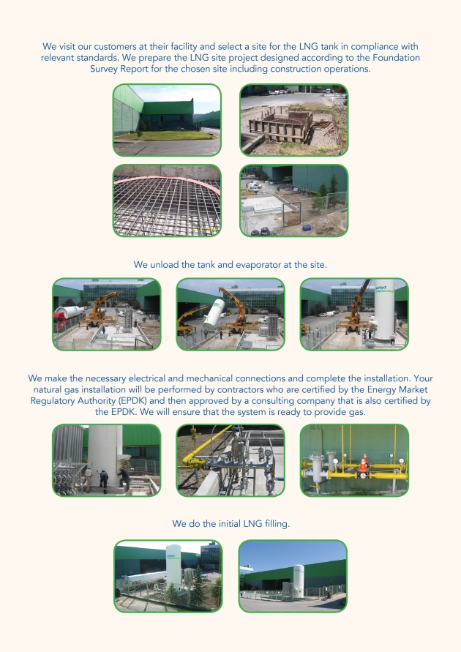

**Figure 6:** **Installation and Activation**

1. **LNG Family**

**3.1 Stock Tank**

This is a cryogenic tank where LNG is stored in liquid form at -162oC and consists of a tank within a tank. The stainless steel tank on the inside is used to store LNG while the external steel tank is used for isolation. Perlite and a vacuum process is used in all of the tanks to minimize the tanks contact with the external environment and maximize efficiency.

## 3.2 Evaporators

In order to ensure a safe and efficient flow of the necessary amount of natural gas, atmospheric evaporators that do not require additional energy are used in the systems. The evaporators used in all of the LNG systems are made entirely of aluminium to minimize your maintenance costs. In areas with extreme weather conditions, evaporators are assisted by electrical heaters. In applications with large volume consumption, hot water evaporators are used.

1. **Technicalities and Safety**

All of the equipment used in LNG systems is certified by third-party institutions. LNG systems are built in compliance with international standards (TS EN 13458) to ensure safety.  
  
The LNG tank area is secured against environmental factors with a wire fence. In view of the possibility that the LNG in the LNG stock tank might be released into the environment, the LNG systems are installed in a tank pool proportionate to the volume of the tank and the environmental conditions.   
  
The static calculations for the tank’s concrete footings and anchorage systems in LNG systems are custom designed to comply with earthquake conditions. LNG tanks and equipment are grounded in accordance with standards against fire and lightning.

Adequate documentation and informational support is provided not only for employees but for gas users as well, and during the installation of the LNG facility, applied training describing the system is provided both during activation of the system and afterwards when it is operating.  
  
Warning signs and labels related to potential dangers and the measures to be taken are posted in the LNG tank area.  
  
Dry chemical powder fire extinguishers appropriate for the volume of the tank must be available in the LNG systems.  
  
After the system is activated, all types of information sharing and technical support are available 24 hours a day via both telephone, and if necessary, on-site intervention for problems and needs customers may encounter after the system is brought online. In order to minimize unexpected malfunctions, annual equipment maintenance is performed by authorized technical services.

1. **Logistic Fleet**

Systematically coordinates all operational processes in the transmission of LNG to the delivery address. Safe and quality service is provided with CE certified transportation vehicles that are manufactured in accordance with international standards. The real-time location and speed of transportation vehicles are monitored 24/7 with the assistance of a vehicle tracking system. In addition, operators involved in LNG delivery are given special training in order to ensure that LNG operations are conducted in a safe fashion without posing a danger to human health or the environment.

1. **Status**

This is a technological system that monitors the status of your stock tank and conveys the information gathered to headquarters and to you via a GPRS system in order to ensure your energy security.   
The LNG level in the stock tank is continuously measured in a very precise fashion. With STATUS, you can monitor the amount of LNG in your tank and the pressure whenever and from wherever you want using your cell phone.   
  
This allows officials to discern a number of undesirable situations, such as malfunctions that might occur in your LNG system so that the necessary safety precautions and operational measures can be taken. In order to maximize your safety, all of the equipment used in STATUS is certified and complies with international ex-proof standards.

1. **LNG Tariff**

|  |
| --- |
| LNG Wholesale Price = Terminal LNG Sales Price + Delivery Charge + Investment Fee |

**Notes :**  
• 1 m3 of natural gas is equivalent to the volume of 1 m3 of natural gas at 15oC and 1.01325 bars of absolute pressure.  
• Sales prices are based on a top thermal value for natural gas of 9,155 kcal/Sm3.   
• Excluding SCT and VAT.

1. **The advantages of LNG**

* It makes it possible to use natural gas in areas where natural gas is not available via the national delivery network or municipal distribution system.
* It is a more economic source of energy when compared to black products (fuel oil and diesel) and LPG.
* It is suitable for consumer purposes such as process, steam recovery, heating and cooking in sectors like tourism, steel, paper and ceramic.
* Because of it high energy content, the total amount of energy needed is reduced.
* It expands 600 times to reach its gaseous state (1 unit of LNG = 600 units of natural gas).
* A large amount of natural gas can be stored and transported at low pressure.
* It can be used in all burning devices by making minor changes.
* Because it is a clean fuel, it contributes to improved product quality and reduces maintenance costs.

1. **The disadvantages of LNG**[2]

* **Affordability**

LNG energy projects are among the most expensive and technically complicated, so users are likely to face high energy prices if it makes greater use of LNG shipments. Affordability will be therefore an important consideration in the fuel-mix decisions concerning LNG.

* **Energy efficiency and greenhouse gas emissions**

The LNG supply chain tends to be more energy and greenhouse gas intensive than the supply chain for pipeline gas, because of the extra processing steps. The difference is narrower when LNG is compared to remote pipeline deliveries. Typically the greenhouse gas performance gap is smaller than the energy efficiency gap, because of the unavoidable methane leaks from pipelines. LNG may be more favorable with respect to greenhouse gases compared to pipeline supplies under certain conditions, e.g. when the alternative is very remote pipeline deliveries of gas or when LNG is brought to the end-users in liquid form and then re-gasified on-site.

**Quality**

LNG is of superior quality to pipeline gas, because it is purer, has higher methane and energy content, and has a more stable composition. However, the superior quality of LNG, obtained at a higher cost in terms of energy and greenhouse gas emissions, actually represents a problem in Europe today.

**Shipping**

LNG shipping costs tend to be the most volatile cost component in the overall LNG supply chain and have a major impact on the competitiveness of LNG supplies. LNG is unlikely to cause significantly more shipping congestion, even if more ships are needed to meet greater demand, unless more stringent safety and security rules for handling LNG carriers are introduced. The ships are likely to face the challenges of skilled crew shortages.

**Reference:**

[1]"Liquefied Natural Gas: Advantages And Drawbacks", *Science Daily*, (2017, 26/03/2017). Available: <https://www.sciencedaily.com/releases/2009/07/090707094816.htm>

[2]"Aygaz Doğal Gaz LNG Family", *Aygazdg.com.tr*, 2017. Available: https://www.aygazdg.com.tr/content/EN/aygaz-dogal-gaz-lng-family/102/